**“Insights in CRM Software”**

A Project submitted to the



**Department of Mathematics**

**Savitribai Phule Pune University**

In partial Fulfillment of the requirements for the degree of

**M. Sc.** (Industrial Mathematics with Computer Applications)

By

**Mr. Avinash Kale**

Roll No. 19212  
Seat No. R19092011

Under the guidance of

**Mr. Sunil Kelkar**Sr. Development Manager Prorigo Software Pvt. Ltd.

**Mr. Rahul Lakhangaokar**Director, Software Development Prorigo Software Pvt. Ltd.

**CERTIFICATE**

This is to certify that the project titled “**Insights in CRM Software**” submitted for the degree of M.Sc. (Industrial Mathematics with Computer Applications) to the Department of Mathematics, Savitribai Phule Pune University, Pune-411007, India, is carried out by   
Avinash Kale at **Prorigo Software Pvt. Ltd.** Company under the supervision of **Mr. Sunil Kelkar** and **Mr. Rahul Lakhangaokar** during the academic year 2021-2022. The study material that has been obtained from other resources is duly acknowledged in this project.

Avinash Kale Mr. Kishore Kumar  
 Head-HumanResource  
 Prorigo Software Pvt Ltd

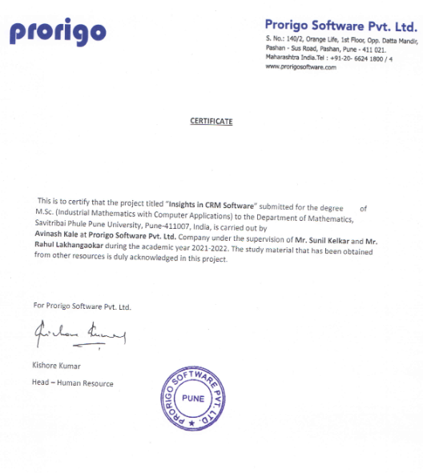

**CERTIFICATE**

This is to certify that **Mr. Avinash Kale** studying in .M.Sc.(Industrial Mathematics with Computer Applications), Department of Mathematics, Savitribai Phule Pune University, Pune successfully completed the internship project titled “**Insights in CRM Software”** in fulfillment of the requirement for the completion of .M.Sc. (Industrial Mathematics with Computer Applications) course conducted by the Department of Mathematics for the academic year 2021-2022.

(Internal Examiner) (External Examiner)

Contents

* Preface 06
* Acknowledgements 07
* Company Profile 08
* Introduction 09
* Significance 12
* Technologies Used 15
* Project Overview 17
* Working on 20
* My Contribution 22
* Conclusions and Future Scope 36
* Bibliography 37

Preface

This is an internship report for completing my M.Sc.(IMCA) degree. I have done an internship in Prorigo Software PVT LTD. During my internship period, I was working on a Syncron project. The project is based on CRM Software.

A CRM system gives everyone — from sales, customer service, business development, recruiting, marketing, or any other line of business — a better way to manage the external interactions and relationships that drive success. A CRM tool lets you store customer and prospect contact information, identify sales opportunities, record service issues, and manage marketing campaigns, all in one central location — and make information about every customer interaction available to anyone at your company who might need it.

With visibility and easy access to data, it's easier to collaborate and increase productivity. Everyone in company (e.g.-OEM) can see how customers have been communicated with, what they’ve bought, when they last purchased, what they paid, and so much more. CRM can help companies of all sizes drive business growth, and it can be especially beneficial to a small business, where teams often need to find ways to do more with less.

Acknowledgments

I am thankful to Prorigo Software Pvt. Ltd. For giving me this opportunity to work and learn in such a big and esteem firm. I am thankful to Mr. Sunil Kelkar and Mr. Rahul Lakhangaokar for providing me invaluable supervision, timely suggestions and inspired guidance and in bringing this project to successful completion.

I would like to express deepest appreciation towards Miss. Suzanne Christian and other team members who helped me providing wonderful working environment.

Special thanks to Mrs. Smita Kandekar for encouragement, valuable suggestions and support and also for arranging presentations on project and providing guidelines. I am grateful to Professor Vinayak Joshi, Head of the Department for permitting us to make use of facilities available in the department to carry out the project successfully.

Company Profile

Prorigo Software Pvt. Ltd.

Prorigo Software, established in the year 2008, is a technology company providing outsourced software product development and customized application development services.

Prorigo’s technology focus and significant experience in building robust, scalable and world class software products and applications helps them to bring your products to market faster and maintain them – be it a social networking site, a mobile application, a desktop product or a complete "n" tiered enterprise product. They also provide professional services for extending off-the-shelf technologies and bespoke applications, including architecture, program management, enterprise integrations and data migration.

Prorigo has experts in Cloud & Mobile application architecture, along with technical experts in Microsoft, Enterprise Java technologies, native & cross-platform mobile technologies. Over the past decade, they have acquired excellent expertise in various domains like Customer Relationship Management (CRM), Governance Risk & Compliance (GRC), Product Lifecycle Management (PLM), eCommerce and Supply Chain Management (SCM)

Introduction

A CRM system gives everyone from sales, customer service, business development, recruiting, marketing, or any other line of business — a better way to manage the external interactions and relationships that drive success. A CRM tool lets you store customer and prospect contact information, identify sales opportunities, record service issues, and manage marketing campaigns, all in one central location — and make information about every customer interaction available to anyone at your company who might need it.

With visibility and easy access to data, it's easier to collaborate and increase productivity. Everyone in company(e.g.-OEM) can see how customers have been communicated with, what they’ve bought, when they last purchased, what they paid, and so much more. CRM can help companies of all sizes drive business growth, and it can be especially beneficial to a small business, where teams often need to find ways to do more with less.

Customer Relationship Management (CRM) is growing in importance due to the challenging business environment faced by organizations throughout the world today. It is particularly critical in industries undergoing changes in traditional channel configuration. CRM is a means of addressing increasing competition, changing economic conditions and promotional dependence through the use of intimate customer knowledge; knowledge gained through relationship development and past marketing programs. CRM is increasing in prominence because it focuses on current users who are the source of the majority of business revenue and the best option for improving business in uncertain times.

There are a number of working definitions for CRM. In fact the letters CRM have been used to identify Continuous Relationship Marketing, Customer Relationship Marketing and Customer Relationship Management. Each term represents the same process. CRM can be defined as a process that maximizes customer value through on-going marketing activity founded on intimate customer knowledge established through collection, management and leverage of customer information and contact history.CRM is about perfecting relationships to maximize a customer’s value over time.

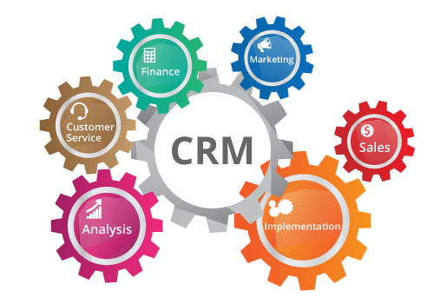

CRM has different components like Marketing, sales, implementation, Analysis, Customer service, Finance etc. I am working on customer service based product. It provide all support after sales therefore it called after sales service solution. The concept of after sales service is as important as sales. While it does not generate any revenue for the company, it surely does increase the goodwill of the organization in the [market](https://www.marketing91.com/market/) and amongst the customers. After-sales service is essential to not only retain the customers but also to bring back lost customers. After sales service could be defined as the processes which are followed post the sale of the [product](https://www.marketing91.com/what-is-a-product/). The nature of the services includes maintenance, guidance, repair etc.

The nature of after sales service depends entirely on the industry and the product. While some may require installation, others may require cleaning every couple of months.

Following are a few steps for goods after sales service:

1. Updating the customers about the nature of after sales service.
2. Updating the customers about the transit of the [goods](https://www.marketing91.com/difference-between-goods-and-services/).
3. Following up with the delivery team to ensure timely delivery.
4. Following up on new customer or installation.
5. Fast after sales service post complaint.

## Most common types of after sales service:

## Pre-Installation services

## User training

## Warranty services

## Online support

## Return/Replacement

## Features and benefits

## Upgrades

Significance

CRM helps businesses build a relationship with their customers that , in turn, creates loyalty and customer retention. Since customer loyalty and revenue are both qualities that affect a company's revenue, CRM is a management strategy that results in increased profits for a business. At its core, a CRM tool creates a simple user interface for a collection of data that helps businesses recognize and communicate with customers in a scalable way

Companies (OEM) to increase their customer retention and, as a result, their profits? Some of the major ways in which CRM accomplishes this goal are listed below.

**• Learning.**CRM helps businesses learn about their customers, including who they are and why they purchase your products, as well as trends in customers' purchasing histories. This allows businesses to better anticipate their customers' needs and, as a result, fulfill them. Effectively using customer relationship management can also provide a strategic advantage. Well organized customer data helps companies select the correct recipients for promotions and new products.

**• Organization.**CRM allows businesses to become more efficient by organizing and automating certain aspects of the business. From sales processes to marketing campaigns and business analytics as well as customer data, CRM automates and streamlines these processes for businesses. This allows the businesses to organize these processes into simpler, easier to understand data.

**• Optimization.**Finally, CRM software allows businesses to optimize their customer interactions. By simplifying and streamlining many of the more complex customer interaction processes, CRM increases customer satisfaction.

**After sales service**

After-sales service refers to the treatment of customers in the aftermath of a sale. For example, after being sold a bike, after sales service may involve free bike maintenance for a number of weeks.

After sales service is an important part of non-price competition often found in oligopoly . After sales service can be a way to encourage people to buy the product in the first place; it can be used to justify a higher price for the good. It also influences the long-term reputation of the firm and can influence future sales. However, it also imposes costs on firms.

**Examples of after sales service**

* Warranty. A common example of after sales service is the provision of a warranty for the good. A warranty allows the goods to be repaired or replaced if it breaks down within a certain period of time after purchase.
* Free service after six months (e.g. car/bike)
* Advice on how to use the product (Apple care)

Firms following up with a phone call to the customer asking how the product is working out

### Importance of after-sales service

* Goods after sales service helps improve firms long-term brand image and brand loyalty.
* Offering after sales service can help to convince consumers to trust the firm and buy the service in the first place.
* Sales affected by word of mouth recommendation. Good after sales service can make difference. In an era of social media – poor after sales service can be damaging to reviews and reputation of firms.
* After sales service imposes extra cost on firms. For firms, they need to strike a balance between keeping the customer happy and not being burdened with expensive maintenance. For example, a firm may offer one free service, but then have a clearly defined price for future service.
* The provision of after sales service varies in importance depending on the type of good. For example, after sales service and extended warranties are important for goods like electrical goods and new cars.
* After sales service can also become an opportunity to sell related products.

Technologies Used

1. MySQL

MySQL is the most popular Open Source Relational SQL database management system. MySQL is one of the best RDBMS being used for developing web-based software applications.

1. Eclipse IDE

Eclipse is an integrated development environment (IDE) used in computer programming. It contains a base workspace and an extensible plug-in system for customizing the environment. It is the second-most-popular IDE for Java development, and, until 2016, was the most popular. Eclipse is written mostly in Java and its primary use is for developing Java applications but it may also be used to develop applications in other programming languages via plug-ins, including C, C++, C#, JavaScript, Perl, PHP, Python, R, , Scala etc.

1. Apache Activiti

Activiti is an Apache-licensed business process management (BPM) engine. Such an engine has as core goal to take a process definition comprised of human tasks and service calls and execute those in a certain order, while exposing various API’s to start, manage and query data about process instances for that definition.

Activiti is an open-source workflow engine written in Java.

1. Apache Solr

Solr is an open-source enterprise-search platform, written in Java. Its major features include full-text search, hit highlighting, faceted search, real-time indexing, dynamic clustering, database integration, NoSQL features and rich document (e.g., Word, PDF) handling.

1. Jasper Report  
   JasperReports is an open source Java reporting tool that can write to a variety of targets, such as: screen, a printer, into PDF, HTML, Microsoft Excel, RTF, ODT, comma-separated values (CSV)or XML files.
2. Postman

Postman is an application used for API testing. It is an HTTP client that tests HTTP requests, utilizing a graphical user interface, through which we obtain different types of responses that need to be subsequently validated.

Project Overview

(Mize- After-Sales service solution)

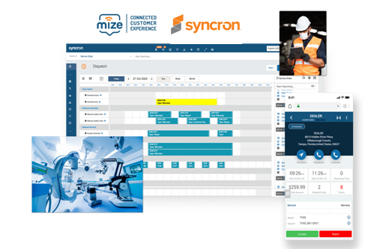

Mize is a leader in Service Lifecycle Management, providing a cloud-based solution for durable goods  
manufacturers and their value chain. The company provides a Connected Customer Experience among OEMs  
and their end customers, dealer channels, service provider network and suppliers, connecting and managing  
all service lifecycle interactions, extending across Warranty, Service Plans, Support, Service Delivery, Parts, and  
Returns. This results in reduced operational cost, with optimized customer experience and maximized lifetime  
value.

I am working on a Project for an After-Sales service solution for **Syncron** .Mize is merge with Syncron.

Syncron is an after-sales service solution provider with a global presence. Syncron's global headquarters are located in Stockholm, Sweden,other countries.

Syncron serves multinational manufacturing and distribution companies that operate within different industry sectors.

* Aerospace and defense
* Agricultural equipment
* Automotive
* Energy and utilities
* Electronics
* Industrial equipment
* Medical
* Mining and construction equipment
* Third party logistics
* Wholesale and distribution

Working on

Dealer Credits & Returns Management project

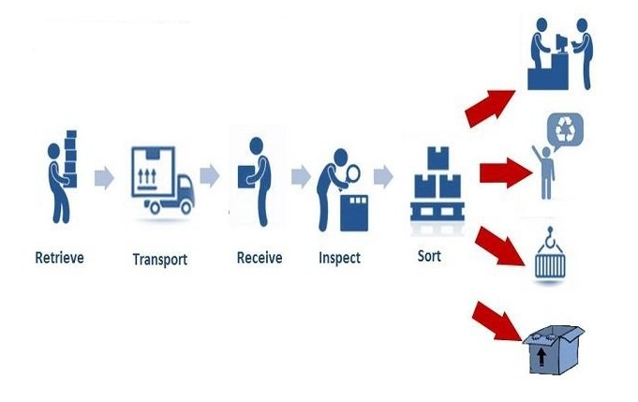

We are working on DCRM .when Dealer wants to return the some material to its OEM .some of screen shot added of workflows.

When return material is received following workflow is executed in activiti .

RMA%20Process%20Flows.pdf

When RMA (Return Merchandise Authorization) is generated that RMA has five different process that will be executed.

My Contribution

Workflow

In joining the Internship I have gone through this workflow. I received basic HTML, CSS, JavaScript, and java training in basic training.

for the project training, I received Spring boot framework training, MySQL, Apache Activiti, Apache Solr, and other essential training

Basic Training

* Created some webpages using CSS , HTML , JavaScript
* Tested API’s using Postman

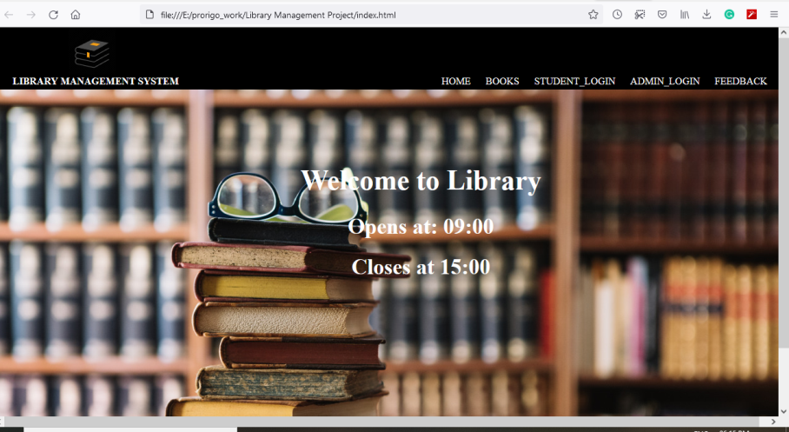

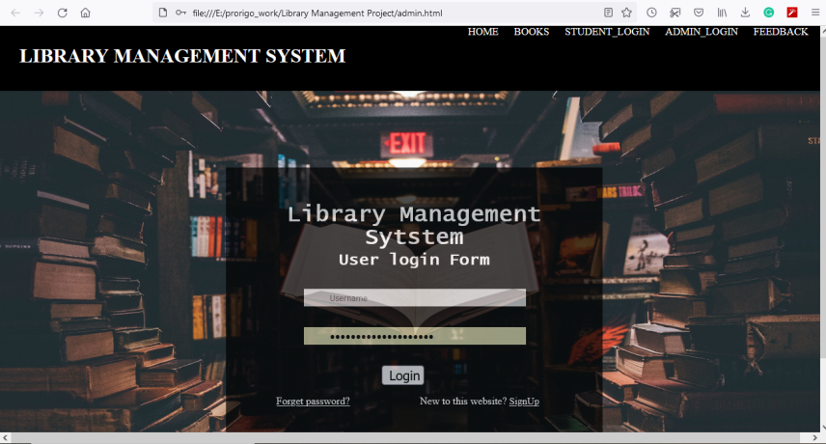

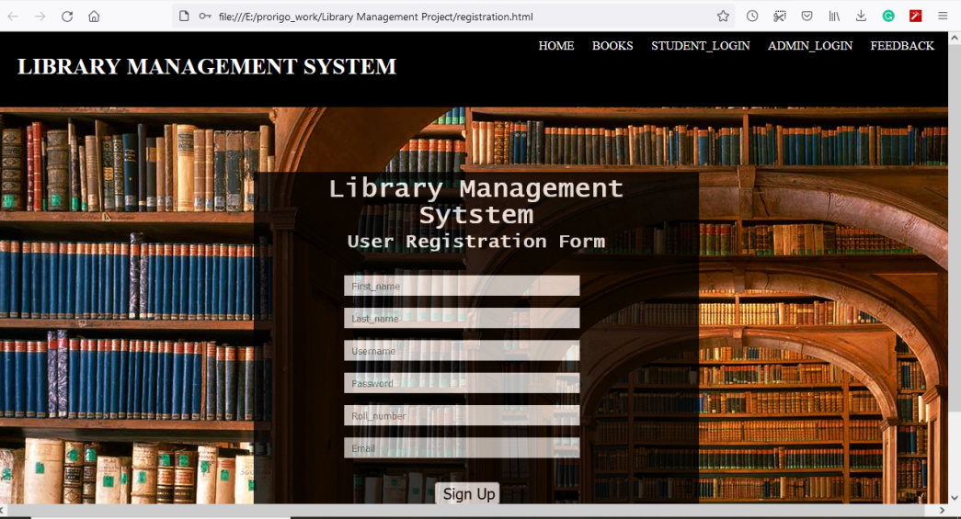

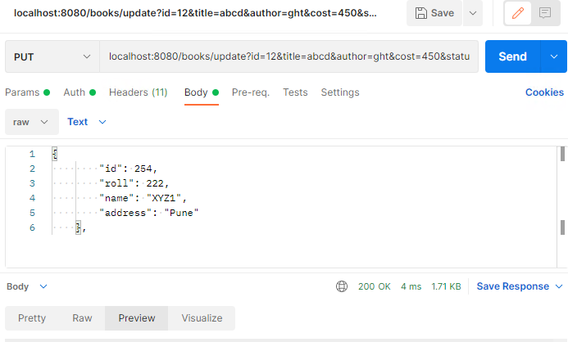

* Created CRUD Java Console application
* Created CRUD application using spring boot

Created Library Management System Project using Spring boot , Spring Security, Spring JPA , MySQL , Thymleaf template ,Jasper report

I have created project Library Management System. Responsibilities for that project are to Development of the front end, Implementation and Bug fixes, Database creation , Testing the functionalities Tools and Technologies used MySQL, Spring Boot, HTML, CSS, and JavaScript.

Overview of that project is

Library Management System stores and manages information about books present in library, their authors and the records of student who issued book from library as well library staff. This system has been designed to computerize and automate the operations performed over the information of students i.e. Members of library, to manage records and overall maintenance of data.

Library management system provides functionality to issue a book to student, add new books to library, maintain records for members who issued a book; also generate issued books reports and maintains fine related records

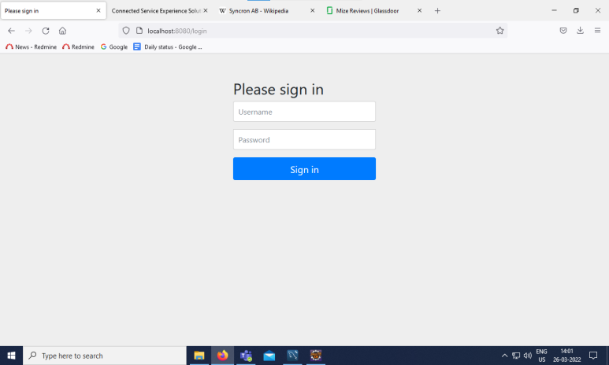

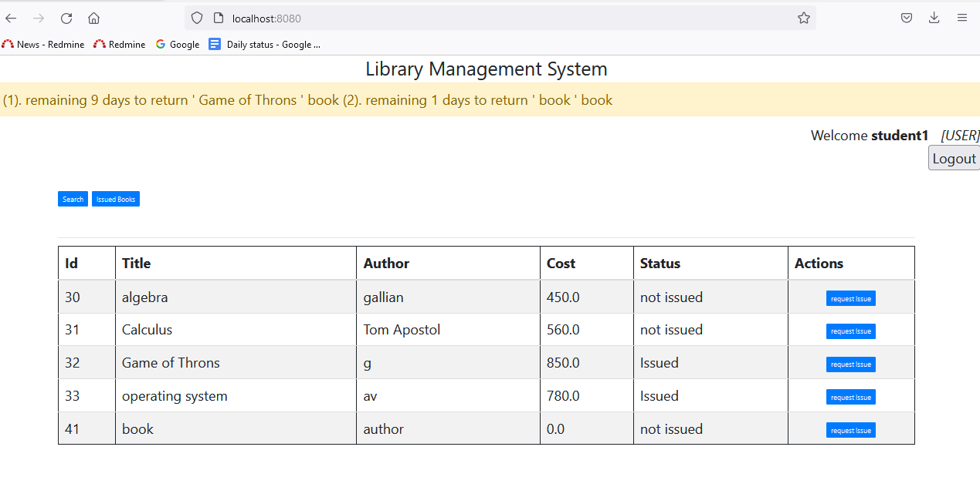

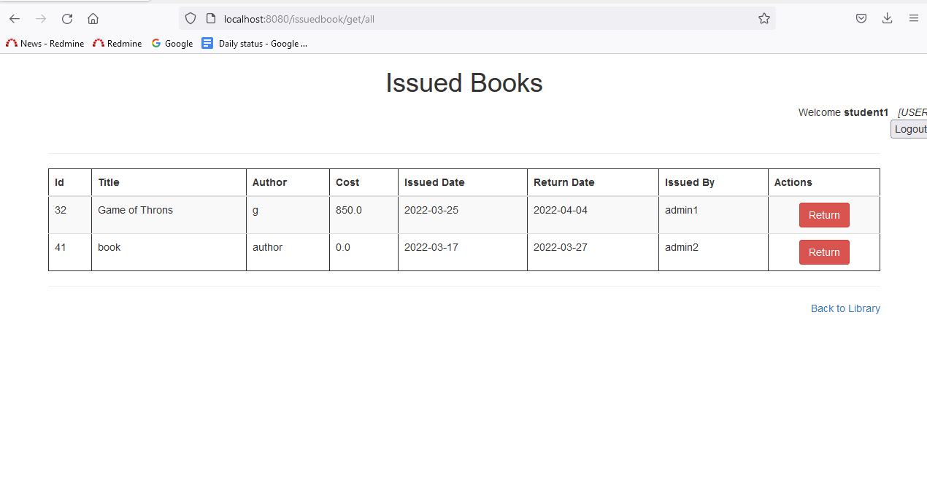  
  
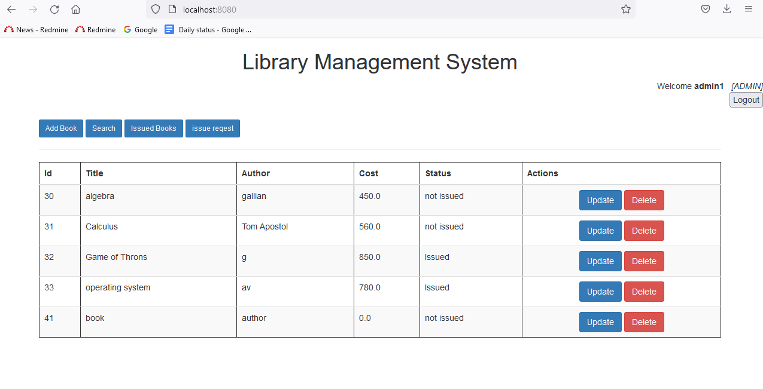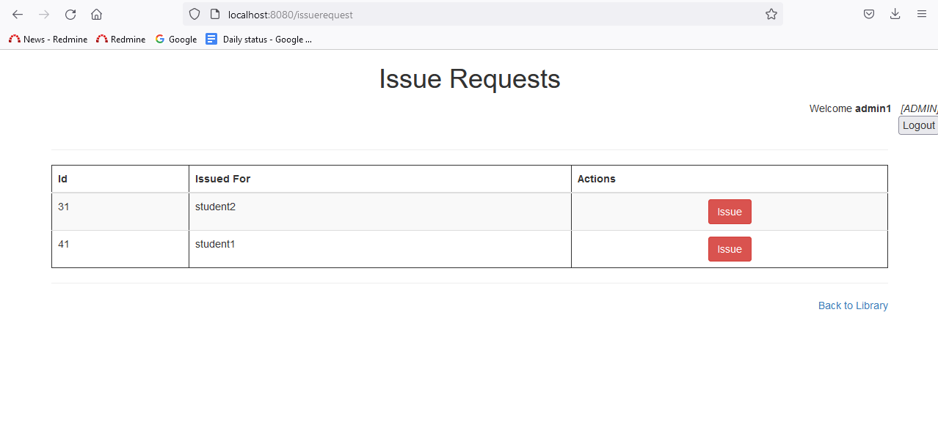

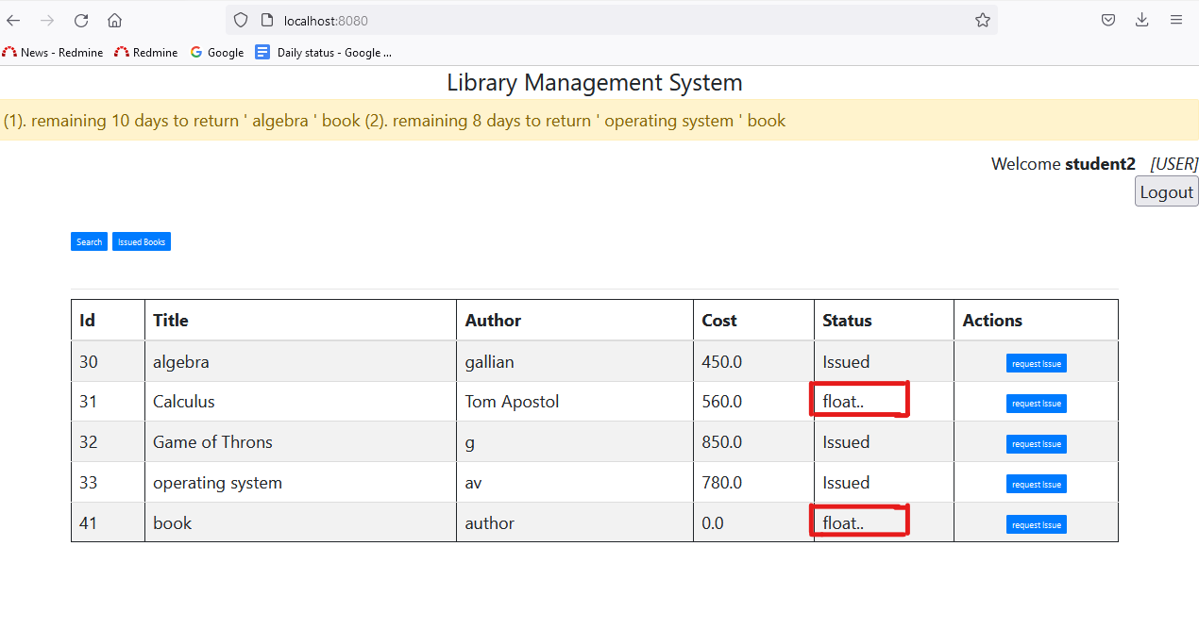

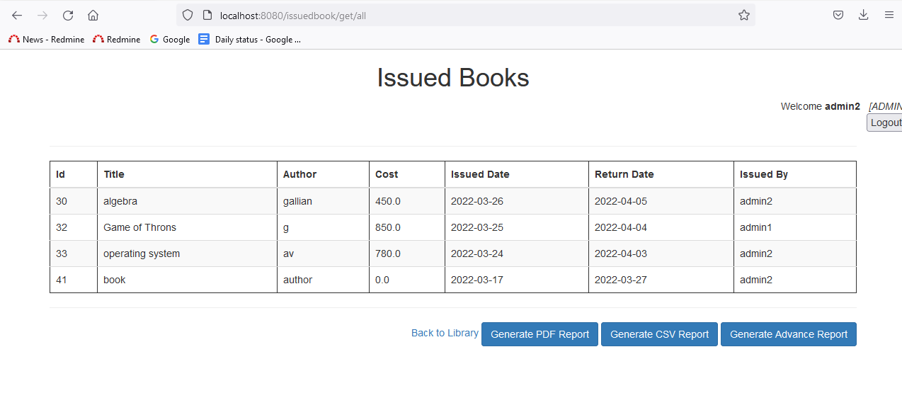  
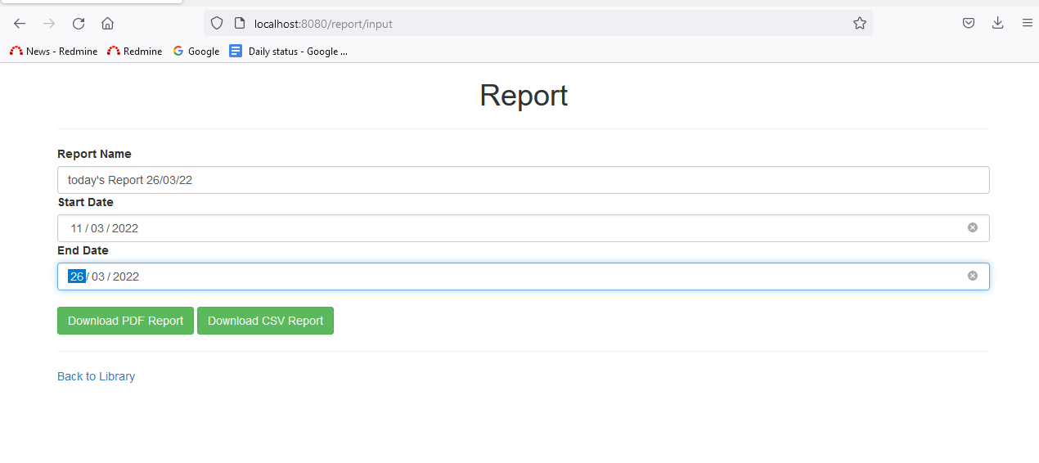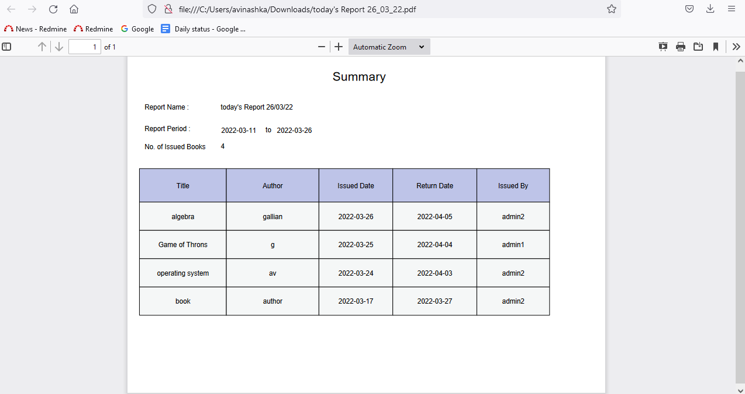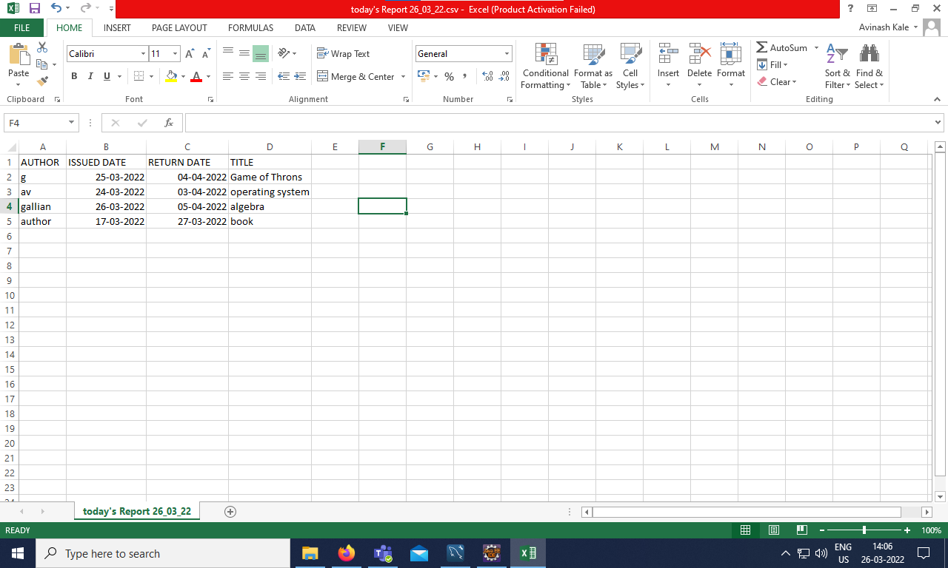

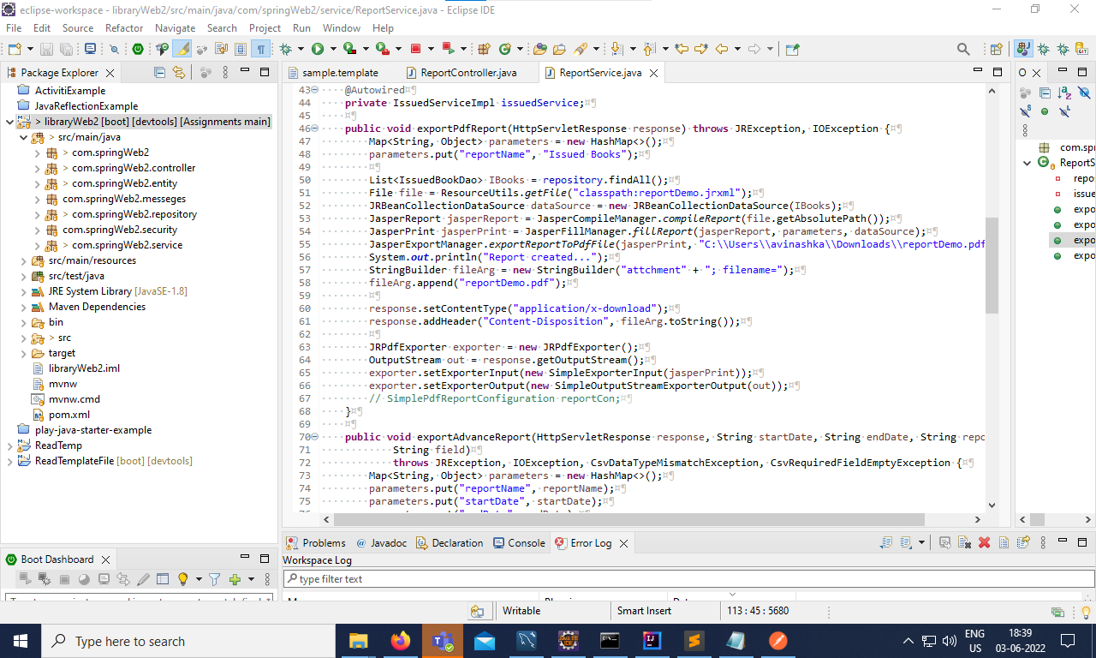

This many technologies I have learned.

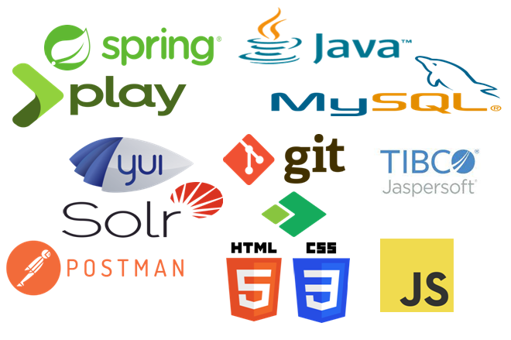

After that I have done the following things in actual live project.

* Understanding business domain
* Review the Java code
* Completing the given tasks, and assignments
* Customize the frontend side
* Check query in Kibana
* Added some validation functions backend
* Created a new screen according to the user story

I have added the screenshots and other screenshots not added due to the NDA (Non-disclosure agreement)binding.

This is the some validation on frontend as well as on backend side 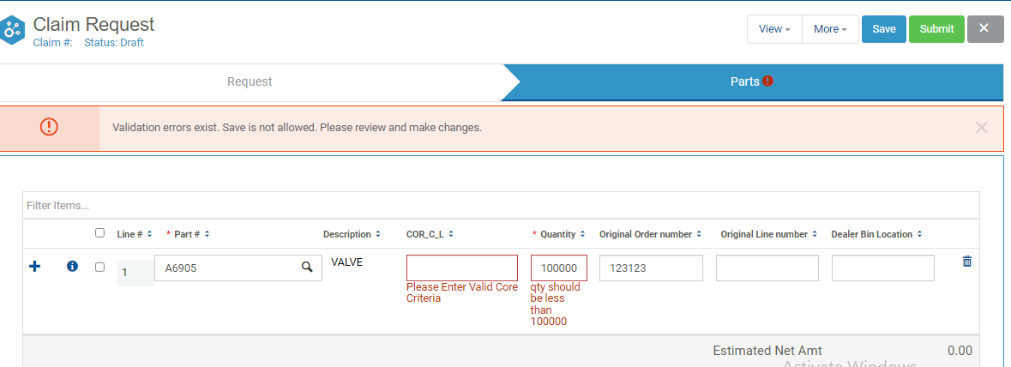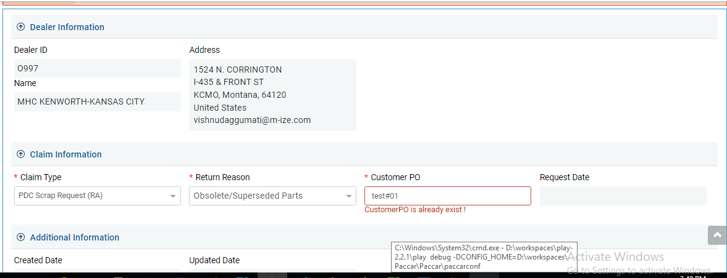

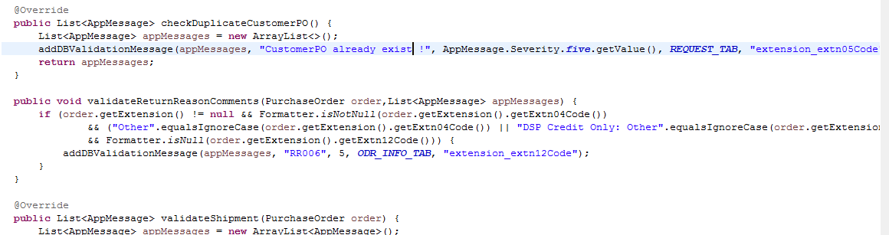

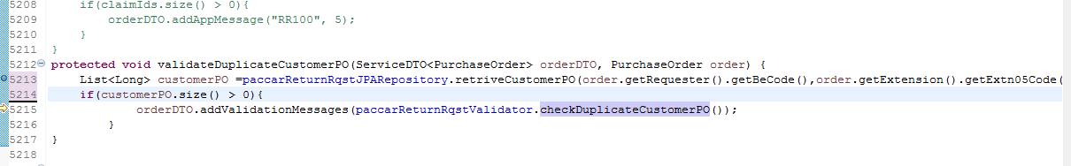

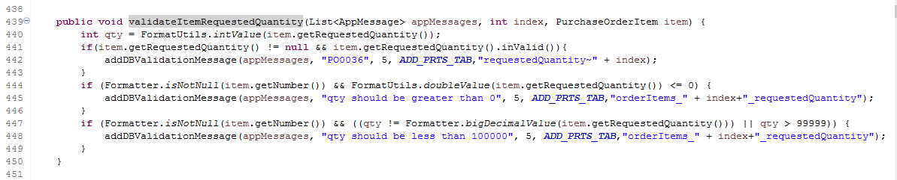

.  
I have added some changes to front end side like text boxes, dropdown, lookup tabs e

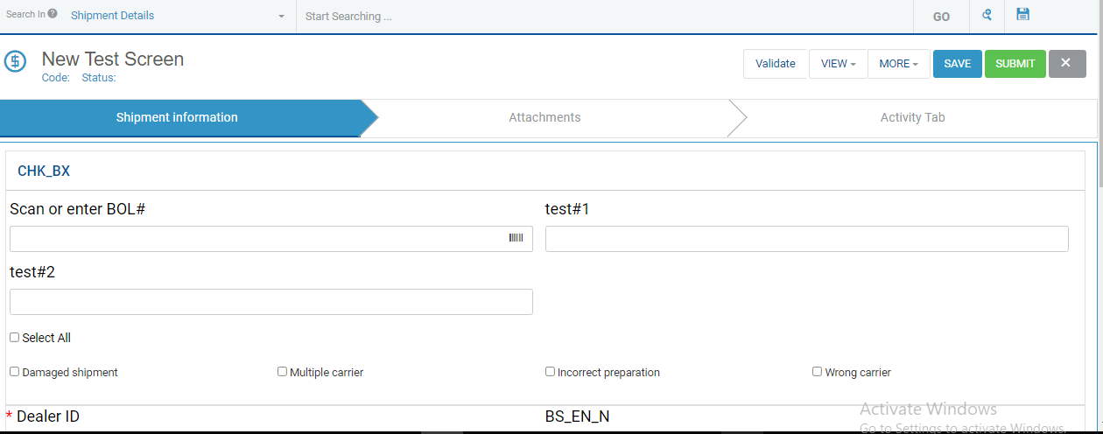

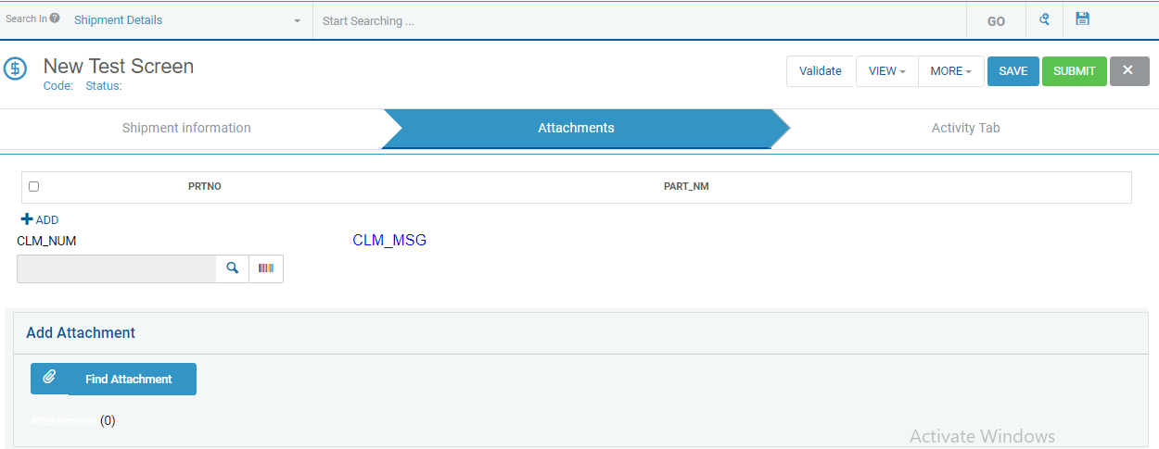

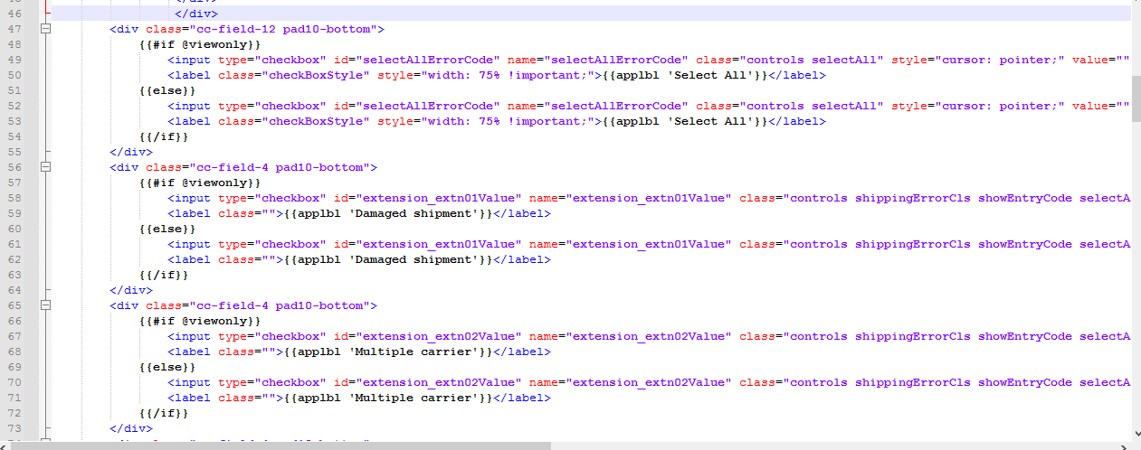

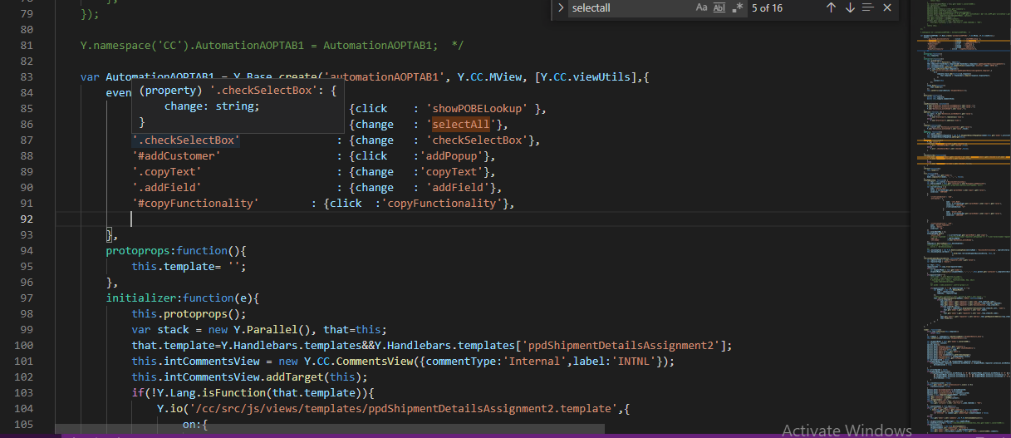

Conclusions And Future Scopes

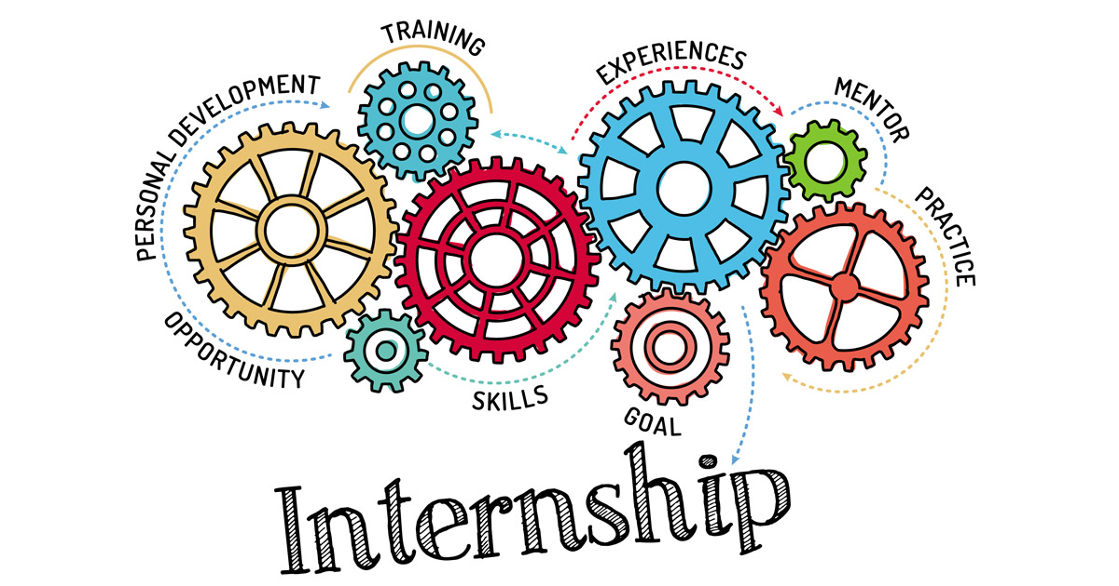

My knowledge Of software development theories was transformed into a series of practical techniques and skills that I can now implement in real-life software development scenarios, all thanks to my internship.  
  
During my internship, I learned how to communicate and build relationships with the people I worked with.

It’s essential to observe others and learn how they engage and interact with co-workers, or help them with projects and tasks. I quickly learned that whenever something is unclear for me, or I don’t understand, it’s fine to ask for clarification.

As an intern, I discovered it’s essential to be enthusiastic and open to learning new skills, asking for more work and being curious to learn and ask questions. This attitude will show that you enjoy being part of the team and that you're keen to help. Having curiosity and enthusiasm also means that, as an intern, you get a lot out of what you’re doing, which opens lots of opportunities

Bibliography

* JavaScript, Html, CSS   
   <https://www.w3schools.com/>
* Java  
   [https://www.java.com](https://www.java.com/)
* GIT   
   <https://git-scm.com/>
* Spring   
  <https://spring.io/>
* Play Framework

<https://www.playframework.com/>

* YUI library   
   <https://en.wikipedia.org/wiki/YUI_Library>
* Apache Activiti   
   <https://www.activiti.org/>
* Solr   
   <https://solr.apache.org/>
* Syncron  
  <https://www.syncron.com/>
* Prorigo   
   <https://www.prorigosoftware.com/>